Air Quality Indicator
Description:
The Air Quality Indicator project detects dust or poor air quality using a simple dust sensor. When dust levels exceed a threshold, an LED indicator turns ON to warn the user. This is a beginner-friendly environmental project demonstrating how sensors can be used to monitor pollution levels indoors.
Block Diagram:
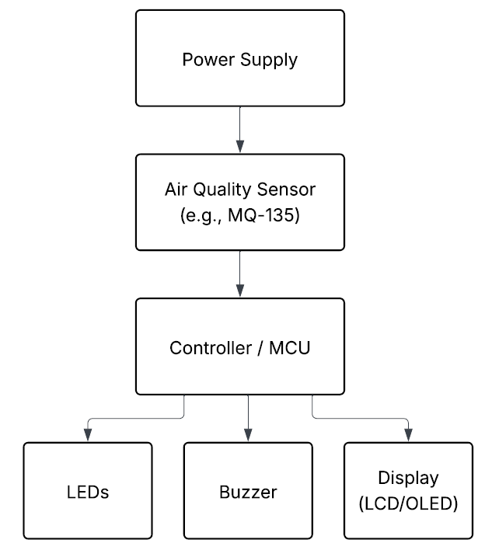
Pinout / Circuit Connection:
- Dust sensor OUT → Arduino A0
- LED → Arduino D9 (via resistor)
- VCC/GND → Arduino power pins
Components Required:
- Arduino UNO
- Dust sensor module (e.g., GP2Y1010AU0F)
- LED
- Resistor (220Ω)
- Breadboard and wires
Working Principle:
The dust sensor measures the concentration of dust particles in the air by detecting reflected infrared light. The output voltage increases with dust density. Arduino reads this voltage and, if it exceeds a threshold, switches ON the LED as an air quality warning.
Operation (Step-by-Step):
- Connect dust sensor to Arduino analog input.
- Upload threshold detection code.
- Place sensor in environment.
- If dust detected → LED lights up.
Code:
int dustLEDPin = 2; // LED control pin of dust sensor
int dustPin = A0; // Analog output pin
float dustValue = 0;
float voltage = 0;
float dustDensity = 0;

void setup() {
Serial.begin(9600);
pinMode(dustLEDPin, OUTPUT);
}

void loop() {
digitalWrite(dustLEDPin, LOW); // Turn ON IR LED
delayMicroseconds(280);

dustValue = analogRead(dustPin); // Read sensor value
delayMicroseconds(40);

digitalWrite(dustLEDPin, HIGH); // Turn OFF IR LED
delayMicroseconds(9680);

voltage = dustValue * (5.0 / 1024.0); // Convert to voltage
dustDensity = (voltage - 0.9) * 1000.0; // µg/m³ (approx)

Serial.print("Analog Value: ");
Serial.print(dustValue);
Serial.print(" | Voltage: ");
Serial.print(voltage);
Serial.print(" V | Dust Density: ");
Serial.print(dustDensity);
Serial.println(" ug/m3");

delay(1000);
}Conclusion:
The Air Quality Indicator project demonstrates how sensors can be applied to health and safety. It raises awareness about pollution and provides a foundation for advanced air monitoring systems with IoT integration.
References:
[1] Sharp, “Dust Sensor GP2Y1010AU0F Datasheet,” 2016. [Online]. Available: https://www.sharp-sbs.com. [Accessed: Sep. 13, 2025].
[2] R. Santos, “Air Quality Monitoring with Arduino,” Random Nerd Tutorials, 2020. [Online]. Available: https://randomnerdtutorials.com/. [Accessed: Sep. 13, 2025].

